**Marion Oaks Recreation Center Registration Form Bomba/Plena Class**

**Thursdays, June 6 – 27th**

**4 Sessions**

**INSTRUCTOR: Niko Montanez**

**Youth 10 & Up – 6:30 pm**

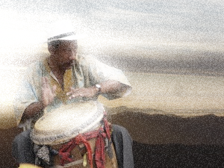

Child’s Full Legal Name ___________________________ D.O.B: ______ Nickname __________________

Address___________________________________ City ____________ ST______ Zip Code ____________

Parent/Legal Guardian Name___________________________ E-Mail Address__________________________

Home Ph#________________ Cell Ph #_________________

Address (if different from above) __________________________________________________________

The following people may pick up my child (other than parent).

Name____________________ Address_________________________________ Phone #_____________

Name____________________ Address_________________________________ Phone #_____________

X____________________________________________________ ___________

Participant’s Signature (parent if applicant is a minor) Date

**Class fee includes: your own djembe and maraca to practice with and keep**

Marion Oaks Recreation Department Only *******************************************************

Method of Payment: Cash ____ Debit/Credit Card (pls circle) Type _________ Amount $_________

Money Order #______________ Staff that took application __________ Staff Processed CC ________

In signing above, I assume risk of harm or injury, which may occur to the participant as a result of participating in event/activity/program. I hereby release Marion Oaks Community Center, Marion Oaks Recreation Center, and its officers, employees, or agents and instructor from any liability, costs and damages resulting from this individual’s participation. I also give consent for Marion Oaks Community Center, Marion Oaks Recreation Center to seek emergency treatment if necessary. I agree to accept financial responsibility for the costs related to this emergency treatment. I also understand that while activity takes place in the Marion Oaks Community Center, Marion Oaks Recreation Center, its representatives and/or Instructor will be taking photos that may be placed on social media, newspapers and other publicity publications.